**Assignment 15.5**

**Build and Deploy hadoop word count program using SBT**

**Input file:**

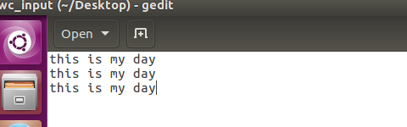

**Step1:** CREATED A Project”wordcount_sbt” IN TERMINAL AND In source/main/java folder added mapper.jav, driver.java, reducer and build.sbt in root.

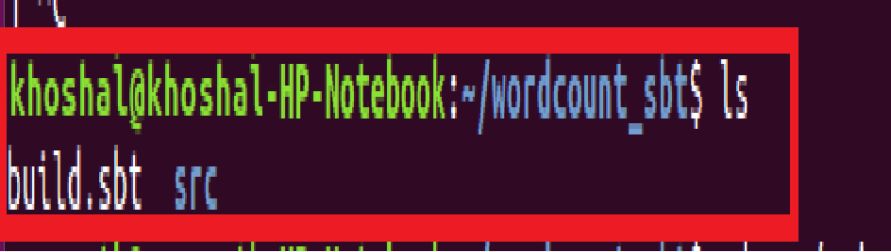

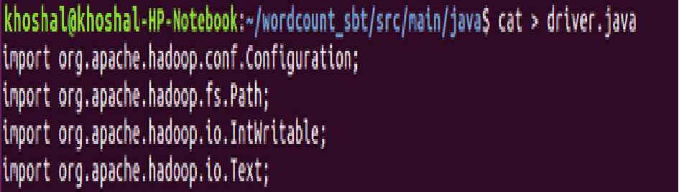

**USE sbt compile command TO build the sbt project:**

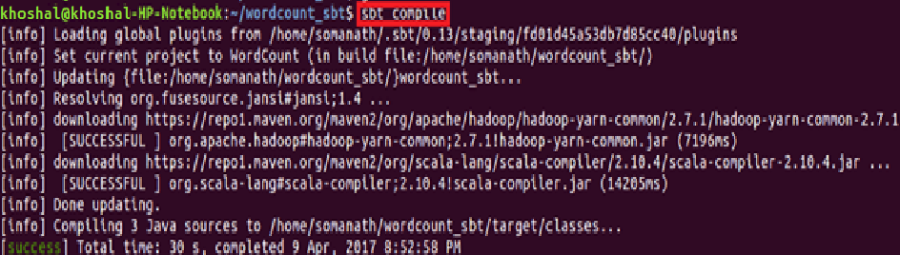

**Step3: Used sbt eclipse to build the project and classpath that are required for eclipse**

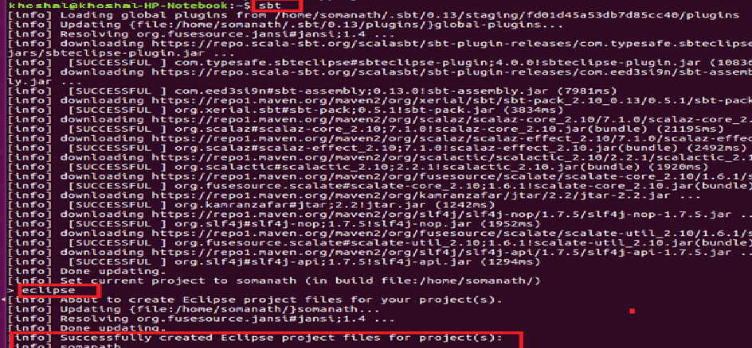

**Step4: Importing project into Eclipse**

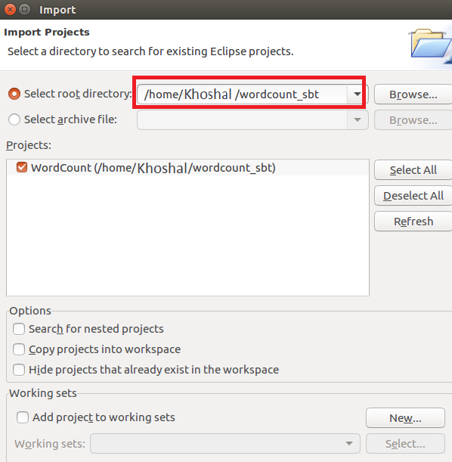

Now we can see in project explorer the wordcount project is converted to **Sbt PROJECT** INSIDE ECLIPSE

**Driver:**

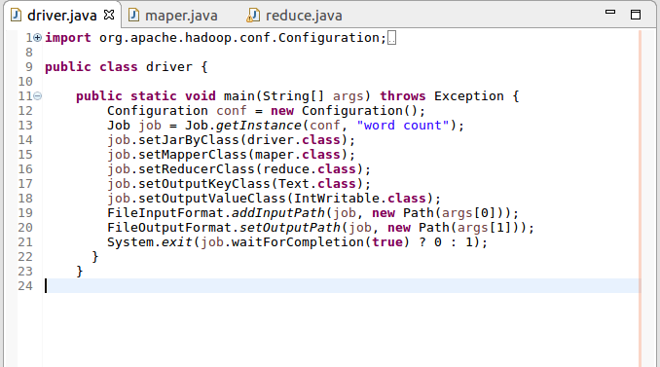

**Mapper:**

In mappersplit the words by space and send word as key and count of 1 as value

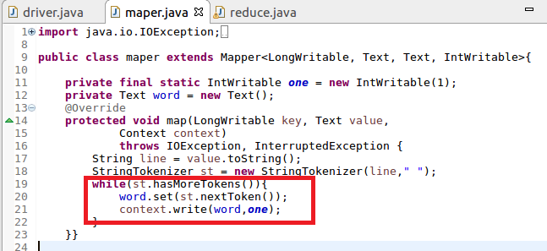

**Reducer:**

Count the total occurrence of words

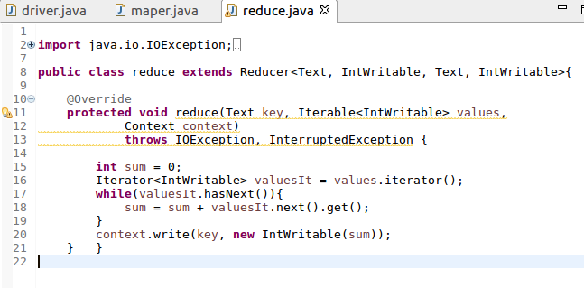

**In root directory added a build.sbt file and added the following dependencies:**

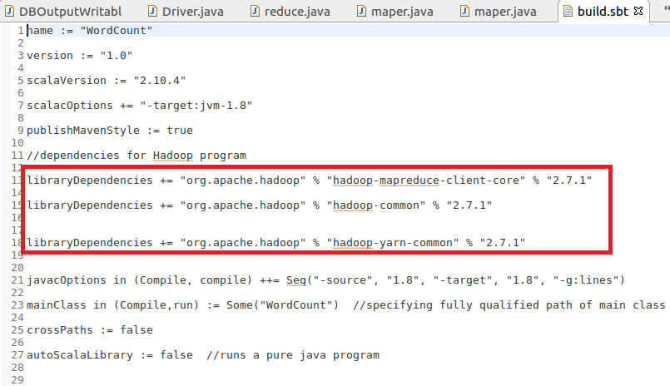

**Step4:**  used **sbt package to** for building the JAR file**.**After successfully packaging the class files as a JAR, you can see the jar file in the **target directory**.

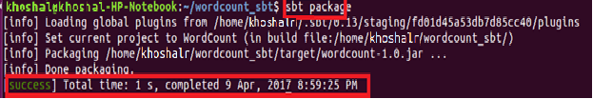

**Step5: Running jar file created by sbt**

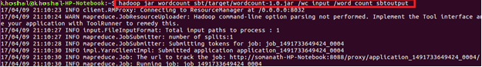

**Output:**

